WEEK 6
Program 1) Write a program to communicate parent and child process with each other in such a way that whenever child writes something, parent process can read it. Consider mode of communication is through.
a. pipe
Source Code:
#include <stdio.h>
#include <unistd.h>
#include <string.h>
int main()
{
int p[2];
int returnstatus;
char writing[2][25] = {"hello", "world"};
char readmsg[25];
returnstatus = pipe(p);
if (returnstatus == -1)
{
printf("Pipe not created\n");
return 1;
}
printf("Writing started: %s\n", writing[0]);
write(p[1], writing[0], strlen(writing[0]) + 1);
read(p[0], readmsg, sizeof(readmsg));
printf("Reading from pipe - msg1: %s\n", readmsg);
return 0;
}

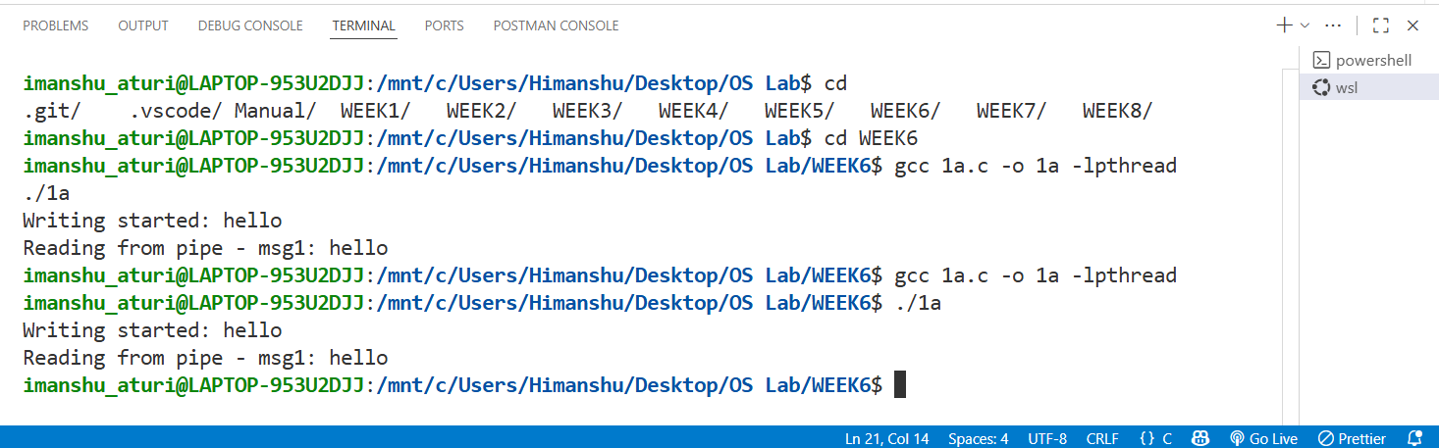
OUTPUT

b) message passing
Source Code:
#include <stdio.h>
#include <stdlib.h>
#include <sys/ipc.h>
#include <sys/msg.h>
#include <string.h>
#include <unistd.h>
struct msg_buffer
{ long msg_type;
char msg_text[100];
} message;
void main()
{
key_t key;
int msgid;
key = ftok("progfile", 65);
msgid = msgget(key, 0666 | IPC_CREAT);
message.msg_type = 1;
if (fork() == 0)
{ strcpy(message.msg_text, "Message from child");
msgsnd(msgid, &message, sizeof(message), 0);
}
else
{ msgrcv(msgid, &message, sizeof(message), 1, 0);
printf("Parent read : %s\n", message.msg_text);
msgctl(msgid, IPC_RMID, NULL);
}
}

OUTPUT

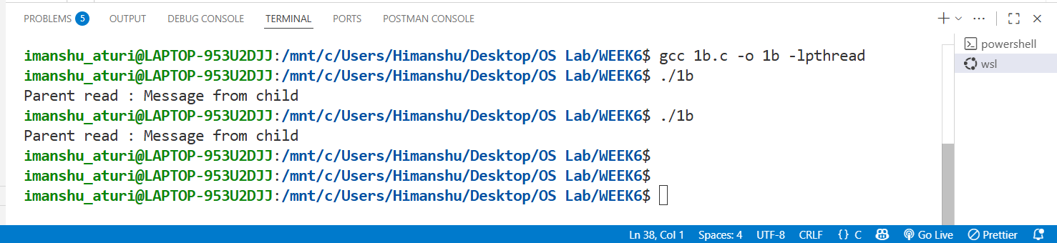

c) shared memory
Source Code:
#include <stdio.h>
#include <stdlib.h>
#include <string.h>
#include <sys/ipc.h>
#include <sys/shm.h>
#include <sys/types.h>
#include <unistd.h>
int main()
{
key_t key;
int shmid;
char *shared_memory;
key = ftok(".", 65);
if (key == -1)
{
perror("ftok");
exit(1);
}
shmid = shmget(key, 1024, 0666 | IPC_CREAT);
if (shmid == -1)
{
perror("shmget");
exit(1);
}
if (fork() == 0)
{
shared_memory = (char *)shmat(shmid, NULL, 0);
if (shared_memory == (char *)(-1))
{
perror("shmat");
exit(1);
}

strcpy(shared_memory, "Message from child process");
printf("Child wrote: %s\n", shared_memory);

shmdt(shared_memory);
}
else
{
sleep(1);

shared_memory = (char *)shmat(shmid, NULL, 0);
if (shared_memory == (char *)(-1))
{
perror("shmat");
exit(1);
}

printf("Parent read: %s\n", shared_memory);

shmdt(shared_memory);
shmctl(shmid, IPC_RMID, NULL);
}
return 0;
}

OUTPUT:

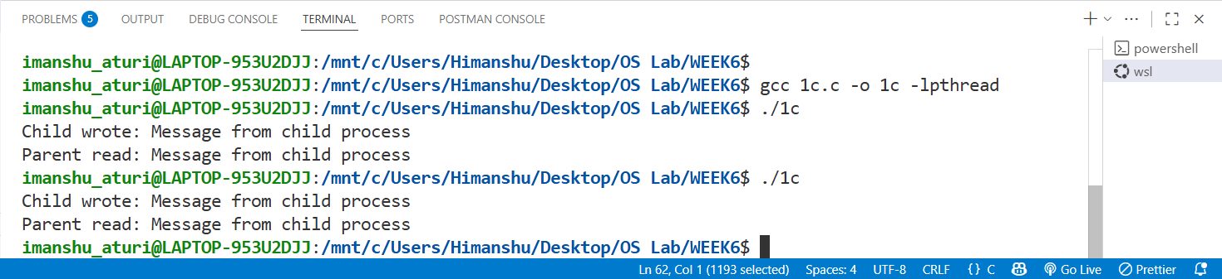

Program2) Write a program to implement the concept of Producer-Consumer problem using semaphores.
Source Code:
#include <stdio.h>
#include <pthread.h>
#include <semaphore.h>
#include <unistd.h>
#define BUFFER_SIZE 5
int buffer[BUFFER_SIZE];
int in = 0, out = 0;
sem_t empty;
sem_t full;
pthread_mutex_t mutex = PTHREAD_MUTEX_INITIALIZER;
void *producer(void *args)
{
int item;
for (int i = 0; i < 10; i++)
{
item = i + 1;
sem_wait(&empty);
pthread_mutex_lock(&mutex);
buffer[in] = item;
printf("Producer produced %d at index %d\n", item, in);
in = (in + 1) % BUFFER_SIZE;
pthread_mutex_unlock(&mutex);
sem_post(&full);
sleep(1);
}
return NULL;
}
void *consumer(void *args)
{
int item;
for (int i = 0; i < 10; i++)
{
sem_wait(&full);
pthread_mutex_lock(&mutex);
item = buffer[out];
printf("Consumer consumed %d from index %d\n", item, out);
out = (out + 1) % BUFFER_SIZE;
pthread_mutex_unlock(&mutex);
sem_post(&empty);
sleep(2);
}
return NULL;
}
int main()
{
pthread_t prod, cons;
sem_init(&empty, 0, BUFFER_SIZE);
sem_init(&full, 0, 0);
pthread_create(&prod, NULL, producer, NULL);
pthread_create(&cons, NULL, consumer, NULL);
pthread_join(prod, NULL);
pthread_join(cons, NULL);
sem_destroy(&empty);
sem_destroy(&full);
pthread_mutex_destroy(&mutex);
return 0;
}
OUTPUT:

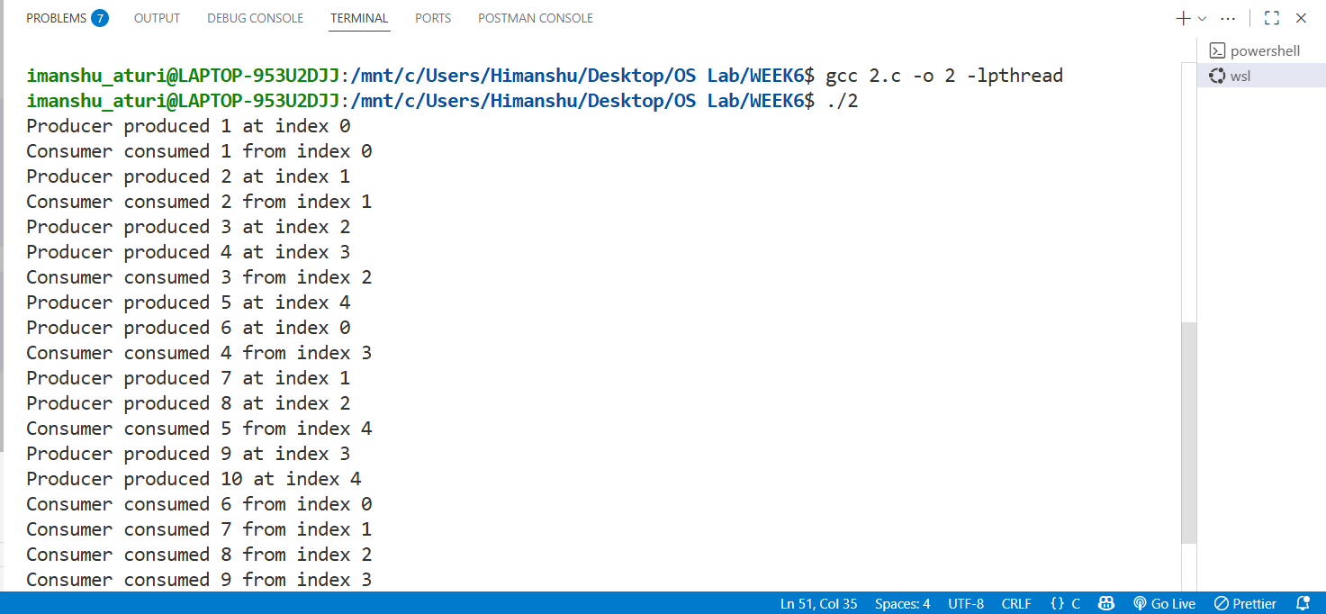

Program3) Write a program to implement the concept of Dining-Philosopher problem.
Source Code:
#include <stdio.h>
#include <pthread.h>
#include <semaphore.h>
#include <unistd.h>
#include <stdlib.h>
#include <time.h>
#define N 5
sem_t chopstick[N];
void *philosopher(void *num)
{
int id = *(int *)num;
while (1)
{
printf("Philosopher %d is thinking\n", id);
sleep(rand() % 3 + 1);
int left = id;
int right = (id + 1) % N;
if (sem_trywait(&chopstick[left]) == 0)
{
if (sem_trywait(&chopstick[right]) == 0)
{
printf("Philosopher %d is eating using chopsticks %d and %d\n", id, left, right);
sleep(rand() % 2 + 1); // eating time
sem_post(&chopstick[left]);
sem_post(&chopstick[right]);
printf("Philosopher %d has released chopsticks %d and %d\n", id, left, right);
}
else
{
sem_post(&chopstick[left]);
printf("Philosopher %d released chopstick %d since right chopstick %d is unavailable\n",
id, left, right);
}
}
else
{
printf("Philosopher %d couldn't pick left chopstick %d, will try again\n", id, left);
}
usleep(200); // small delay to reduce CPU usage
}
pthread_exit(NULL);
}
void main()
{
pthread_t tid[N];
int ids[N];
srand(time(NULL));
for (int i = 0; i < N; i++)
sem_init(&chopstick[i], 0, 1);
for (int i = 0; i < N; i++)
{
ids[i] = i;
pthread_create(&tid[i], NULL, philosopher, &ids[i]);
}
for (int i = 0; i < N; i++)
pthread_join(tid[i], NULL);
}
OUTPUT:

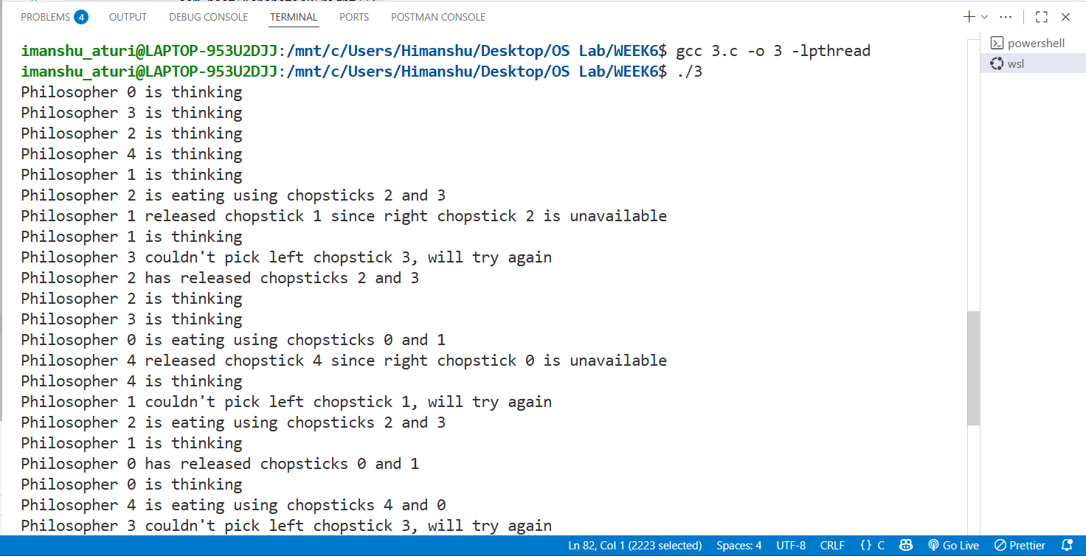

WEEK 7
Program1) FIFO – First In First Out : page which came first (i.e. oldest page) need to be moved out.
Source Code:
#include <stdio.h>
void enqueue(int q[], int *front, int *rear, int v, int n)
{
if (*rear - *front + 1 == n)
{
printf("Queue is full\n");
return;
}else
{
if (*front == -1)
*front = 0;
q[++(*rear)] = v;
}
}
int dequeue(int q[], int *front, int *rear)
{
int v;
if (*front == -1)
{
printf("Queue is empty\n");
return -1;
}
else
{
v = q[*front];
(*front)++;
if (*front > *rear)
{
*front = -1;
*rear = -1;
} }
return v;
}
int isPresent(int q[], int front, int rear, int page)
{
if (front == -1)
return 0;
for (int i = front; i <= rear; i++)
{ if (q[i] == page)
return 1; }
return 0;
}
void display(int q[], int front, int rear)
{
if (front == -1)
{
printf("Queue is empty\n");
return;
}
for (int i = front; i <= rear; i++)
printf("%d ", q[i]);
printf("\n");
}
void main()
{
int n, m;
printf("Enter number of frames: ");
scanf("%d", &n);
printf("Enter number of page requests: ");
scanf("%d", &m);
int pages[m];
for (int i = 0; i < m; i++)
scanf("%d", &pages[i]);
int q[20];
int front = -1, rear = -1;
int pageFaults = 0;
for (int i = 0; i < m; i++)
{
int page = pages[i];
printf("Request for page %d -> ", page);
if (!isPresent(q, front, rear, page))
{ pageFaults++;
if (front == -1 || rear - front + 1 < n)
enqueue(q, &front, &rear, page, n);
else{
dequeue(q, &front, &rear);
enqueue(q, &front, &rear, page, n);
}
printf("Page Fault Frames: ");
} else
printf("Page Hit Frames: ");
display(q, front, rear);
}
printf("\nTotal Page Faults = %d\n", pageFaults);
printf("Total Page Hits = %d\n", m - pageFaults);
}
OUTPUT:

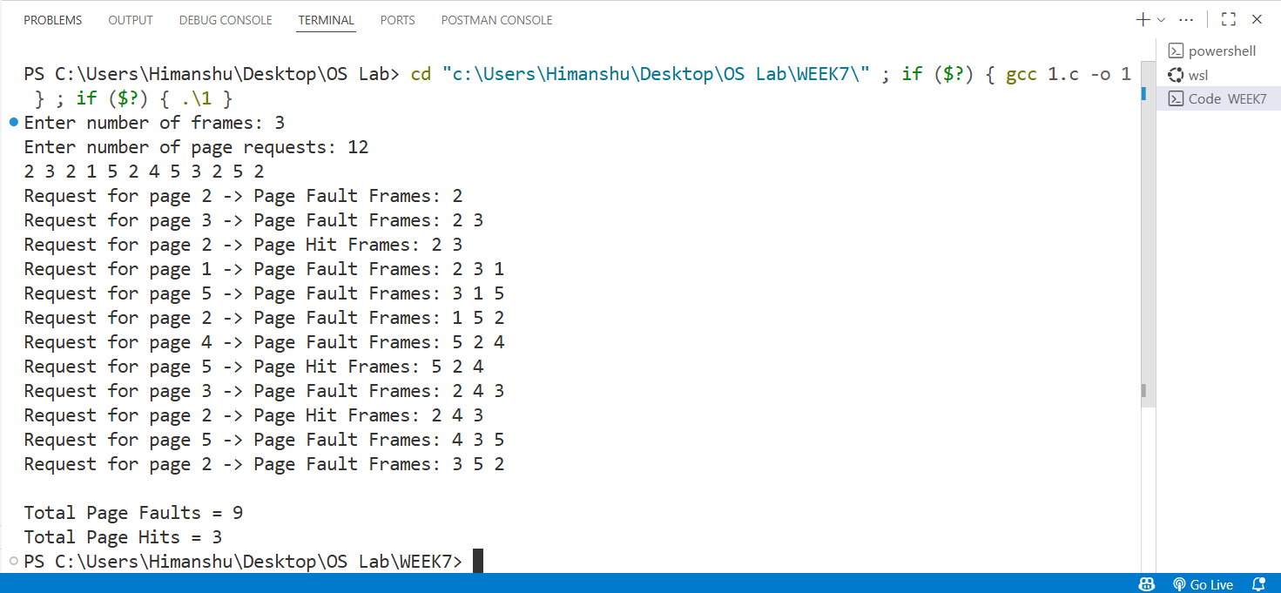

Program2) LRU – Least Recently Used : page which is has not been used for longest Ame need to be moved out.
Source Code:
#include <stdio.h>
int isPresent(int frames[], int n, int page) {
for (int i = 0; i < n; i++) {
if (frames[i] == page)
return 1;
}
return 0;
}
int findLRU(int time[], int n) {
int min = time[0], pos = 0;
for (int i = 1; i < n; i++) {
if (time[i] < min) {
min = time[i];
pos = i; }
}
return pos;
}
void display(int frames[], int n) {
for (int i = 0; i < n; i++) {
if (frames[i] != -1)
printf("%d ", frames[i]);
else
printf("- ");
}
printf("\n");
}
void main()
{
int n, m;
printf("Enter number of frames: ");
scanf("%d", &n);
printf("Enter number of page requests: ");
scanf("%d", &m);
int pages[m];
printf("Enter the page reference string: ");
for (int i = 0; i < m; i++)
scanf("%d", &pages[i]);
int frames[n], time[n];
int counter = 0, pageFaults = 0;
for (int i = 0; i < n; i++)
{
frames[i] = -1;
time[i] = 0;
}
for (int i = 0; i < m; i++)
{
int page = pages[i];
printf("Request for page %d -> ", page);

if (isPresent(frames, n, page))
{
for (int j = 0; j < n; j++)
{
if (frames[j] == page)
time[j] = ++counter;
}
printf("Page Hit Frames: ");
}
else
{
pageFaults++;

int emptyPos = -1;
for (int j = 0; j < n; j++)
{
if (frames[j] == -1)
{
emptyPos = j;
break;
}
}
if (emptyPos != -1)
{
frames[emptyPos] = page;
time[emptyPos] = ++counter;
}else {
int pos = findLRU(time, n);
frames[pos] = page;
time[pos] = ++counter;
}
printf("Page Fault Frames: ");
}
display(frames, n);
}
printf("\nTotal Page Faults = %d\n", pageFaults);
printf("Total Page Hits = %d\n", m - pageFaults);
}
OUTPUT:

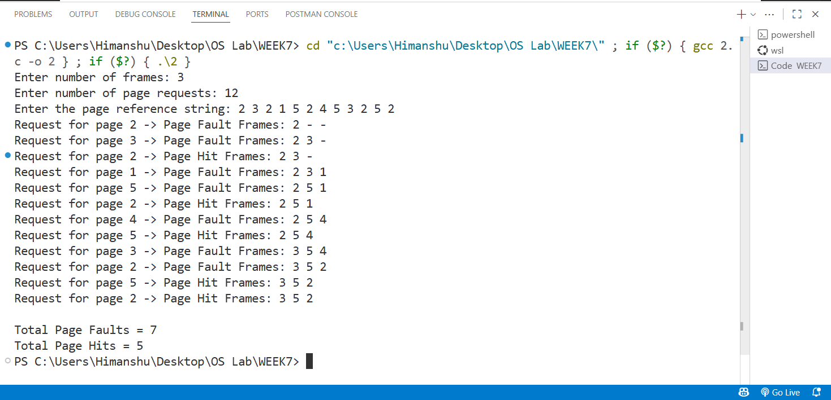

WEEK 8
Program1) Best Fit – block which is closes to the size of request is allocated i.e. the smallest hole that is big enough to allocate to the requesting program.
Source Code:
#include <stdio.h>
int main()
{
int b, p;
printf("Enter number of free blocks available : ");
scanf("%d", &b);
int block[b];
for (int i = 0; i < b; i++)
scanf("%d", &block[i]);
printf("Enter number of processes : ");
scanf("%d", &p);
int process[p];
for (int i = 0; i < p; i++)
scanf("%d", &process[i]);
int allocated[p];
for (int i = 0; i < p; i++)
allocated[i] = -1;
for (int i = 0; i < p; i++)
{
int bestIdx = -1;
for (int j = 0; j < b; j++)
{
if (block[j] >= process[i])
{
if (bestIdx == -1 || block[j] < block[bestIdx])
bestIdx = j;
}
}
if (bestIdx != -1)
{
allocated[i] = bestIdx;
block[bestIdx] -= process[i];
}
}

for (int i = 0; i < p; i++)
{
if (allocated[i] != -1)
printf("%d - %d\n", process[i], allocated[i] + 1);
else
printf("%d no free block allocated\n", process[i]);
}

return 0;
}

OUTPUT:

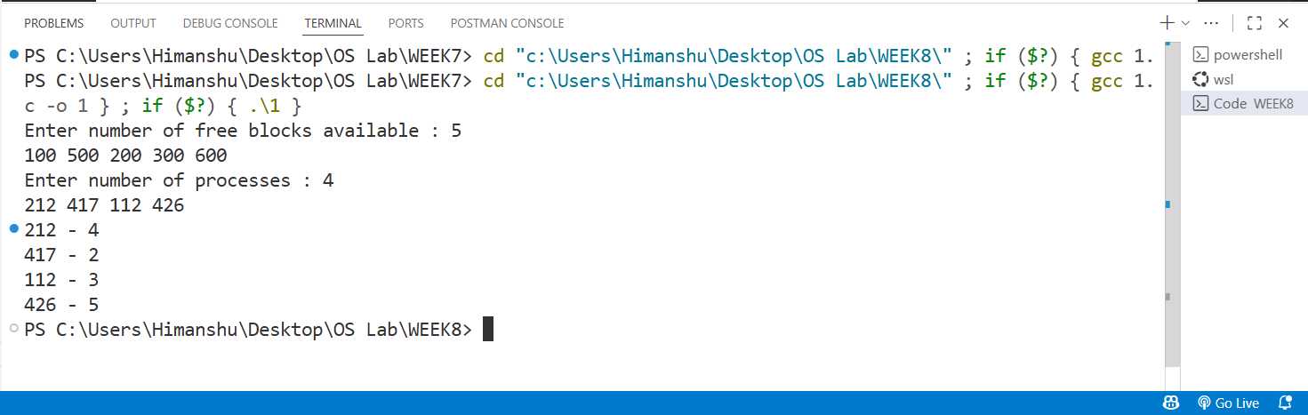

Program 2) First Fit – start searching the list from beginning, take the first block whose size is greater than or equal to the requesting program size and allocate it to program.
Source Code:
#include <stdio.h>
int main()
{
int b, p;
printf("Enter number of free blocks available : ");
scanf("%d", &b);
int block[b];
for (int i = 0; i < b; i++)
scanf("%d", &block[i]);
printf("Enter number of processes : ");
scanf("%d", &p);
int process[p];
for (int i = 0; i < p; i++)
scanf("%d", &process[i]);
int allocated[p];
for (int i = 0; i < p; i++)
allocated[i] = -1;
for (int i = 0; i < p; i++)
{
for (int j = 0; j < b; j++)
{
if (block[j] >= process[i])
{
allocated[i] = j;
block[j] -= process[i];
break;
}
}
}

for (int i = 0; i < p; i++)
{
if (allocated[i] != -1)
printf("%d - %d\n", process[i], allocated[i] + 1);
else
printf("%d no free block allocated\n", process[i]);
}

return 0;
}

OUTPUT:

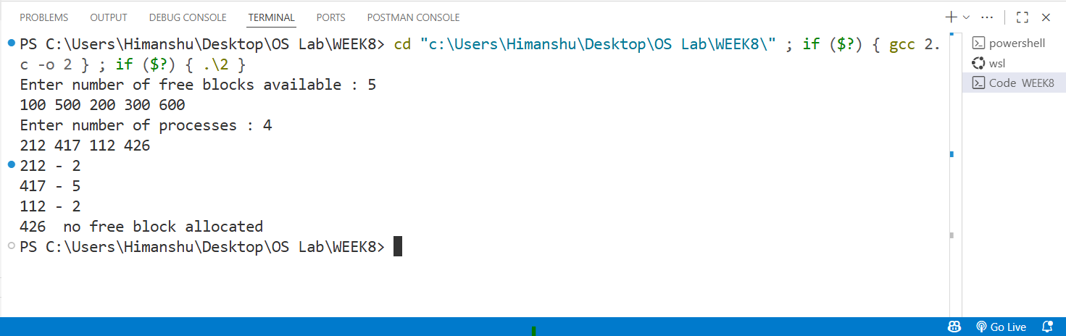

Program3) Worst Fit – block which is largest among all is allocated for the program.
Source Code:
#include <stdio.h>
int main()
{
int b, p;
printf("Enter number of free blocks available : ");
scanf("%d", &b);

int block[b];
for (int i = 0; i < b; i++)
scanf("%d", &block[i]);

printf("Enter number of processes : ");
scanf("%d", &p);

int process[p];
for (int i = 0; i < p; i++)
scanf("%d", &process[i]);

int allocated[p];
for (int i = 0; i < p; i++)
allocated[i] = -1;

for (int i = 0; i < p; i++)
{
int worstIdx = -1;
for (int j = 0; j < b; j++)
{
if (block[j] >= process[i])
{
if (worstIdx == -1 || block[j] > block[worstIdx])
worstIdx = j;
}
}
if (worstIdx != -1)
{
allocated[i] = worstIdx;
block[worstIdx] -= process[i];
}
}

for (int i = 0; i < p; i++)
{
if (allocated[i] != -1)
printf("%d - %d\n", process[i], allocated[i] + 1);
else
printf("%d no free block allocated\n", process[i]);
}

return 0;
}

OUTPUT:

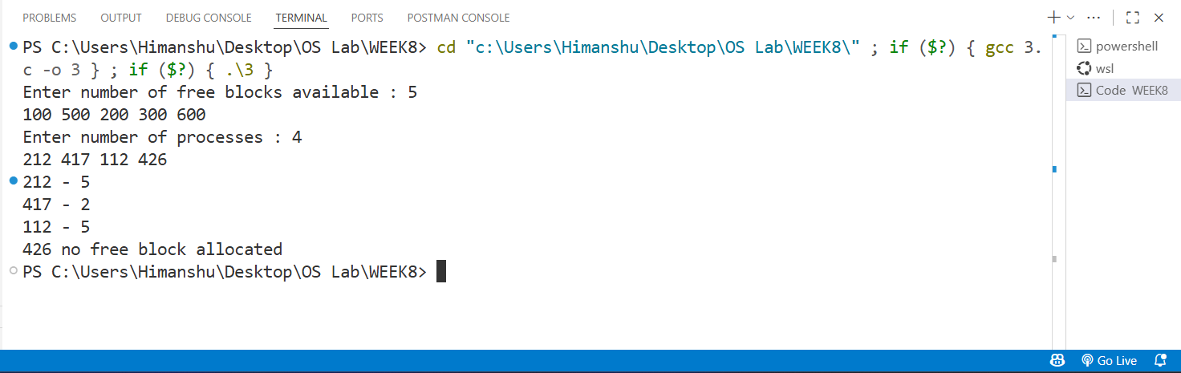

WEEK 9-10
Program1) Write a program to implement Sequential file allocation strategies.
Source Code:
#include <stdio.h>
#include <stdbool.h>
typedef struct file
{
char name;
int start_block;
int no_of_blocks;
} file;
void main()
{
bool blocks[1000] = {true};
int n;
printf("Enter the number of files:");
scanf("%d", &n);
file files[n];
for (int i = 0; i < n; i++)
{
getchar();
printf("Enter the name of file %d:", i + 1);
scanf("%c", &files[i].name);
printf("Enter the starting block of file %d:", i + 1);
scanf("%d", &files[i].start_block);
printf("Enter the no of blocks of file %d:", i + 1);
scanf("%d", &files[i].no_of_blocks);
int st = files[i].start_block;
for (int j = 0; j < files[i].no_of_blocks; j++)
{
blocks[st++] = false;
}
}
char ch;
getchar();
printf("Enter the name of file to be searched:");
scanf("%c", &ch);
bool found = false;
for (int i = 0; i < n; i++)
{
if (files[i].name == ch)
{
printf("File Name : %c\n", files[i].name);
printf("Start Block : %d\n", files[i].start_block);
printf("No. of Blocks : %d\n", files[i].no_of_blocks);
printf("Blocks Occupied: ");
int st = files[i].start_block;
for (int j = 0; j < files[i].no_of_blocks; j++)
{
printf("%d ", st++);
}
found = true;
break;
}
}
if (!found)
printf("File not found");
}

OUTPUT
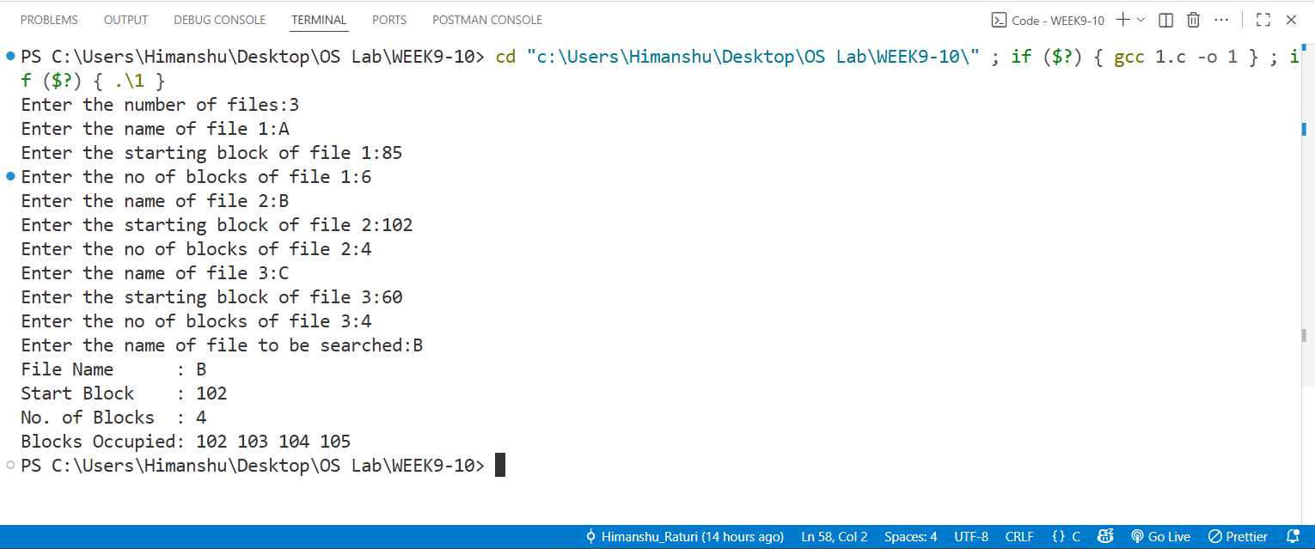

Program2) Write a program to implement Linked file allocation strategies.
Source Code:
#include <stdio.h>
#include <stdbool.h>
typedef struct file{
char name;
int start_block;
int blocks[100];
int no_of_blocks;
} file;
void main(){
bool blocks[1000];
for (int i = 0; i < 1000; ++i)
blocks[i] = true; // true means free
int n;
printf("Enter number of files: ");
if (scanf("%d", &n) != 1 || n <= 0){
printf("Invalid number of files.\n");
return 1;
}
file files[n];
for (int i = 0; i < n; i++) {
printf("\nEnter file %d name: ", i + 1);
if (scanf(" %c", &files[i].name) != 1) {
printf("Invalid file name input.\n");
return 1;
}
printf("Enter starting block of file %d: ", i + 1);
if (scanf("%d", &files[i].start_block) != 1) {
printf("Invalid start block input.\n");
return 1;
}
printf("Enter no of blocks in file %d: ", i + 1);
if (scanf("%d", &files[i].no_of_blocks) != 1 ||
files[i].no_of_blocks < 0 ||
files[i].no_of_blocks > 100) {
printf("Invalid number of blocks (0..%d).\n", 100);
return 1;
}
if (files[i].no_of_blocks == 0) {
printf("No blocks to read for file %c.\n", files[i].name);
continue;
}
printf("Enter blocks for file %d: ", i + 1);
for (int j = 0; j < files[i].no_of_blocks; j++) {
int b;
while (1) {
if (scanf("%d", &b) != 1) {
int c;
while ((c = getchar()) != EOF && c != '\n')
printf("Invalid input. Enter a valid block number: ");
continue;
}
if (b < 0 || b >= 1000) {
printf("Block %d out of range (0..%d). Enter another block: ", b, 1000 - 1);
continue;
}
if (blocks[b] == false) {
printf("Block %d already occupied, enter another block: ", b);
continue;
}
files[i].blocks[j] = b;
blocks[b] = false; // mark occupied
break;
} } }
char ch;
printf("\nEnter the file name to be searched: ");
if (scanf(" %c", &ch) != 1) {
printf("Invalid input.\n");
return 1;
}
bool found = false;
for (int i = 0; i < n; i++) {
if (files[i].name == ch) {
printf("\nFile Found!\n");
printf("File Name: %c\n", files[i].name);
printf("Start Block: %d\n", files[i].start_block);
printf("No. of Blocks: %d\n", files[i].no_of_blocks);
printf("Blocks Occupied (Linked): ");
for (int j = 0; j < files[i].no_of_blocks; j++) {
printf("%d", files[i].blocks[j]);
}
printf(" -> NULL\n");
found = true;
break;
} }
if (!found)
printf("\nFile not found\n");
}
OUTPUT

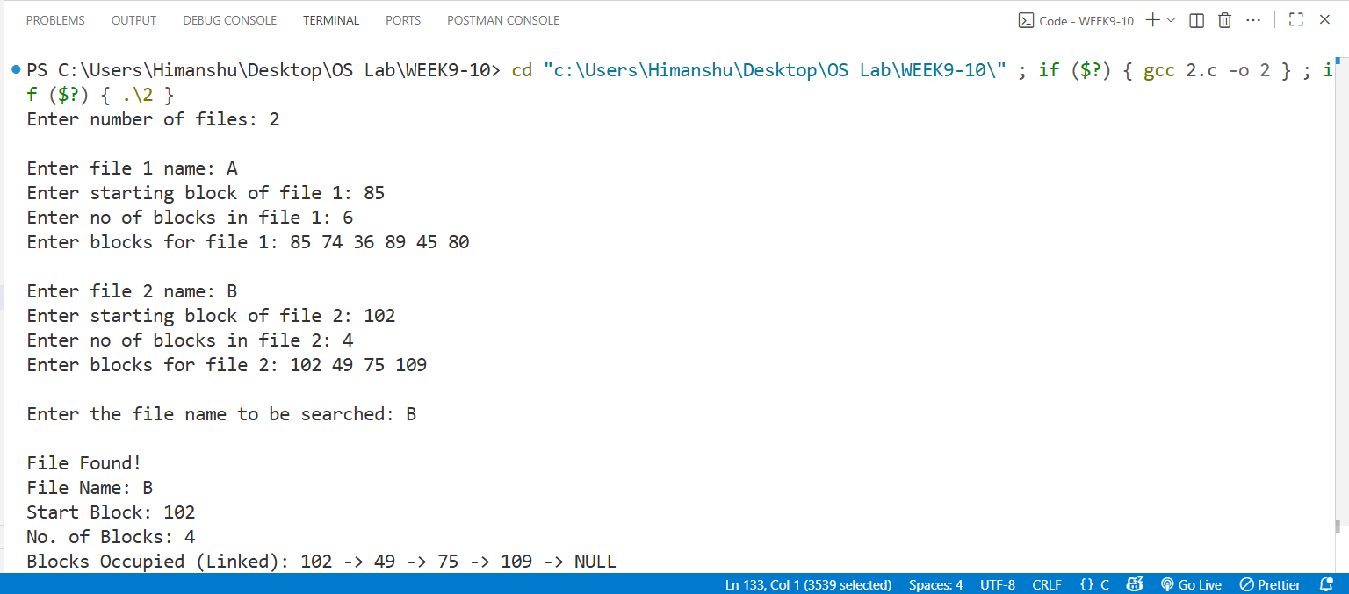

Program3) Write a program to implement Indexed file allocation strategies.
Source Code:
#include <stdio.h>
#include <stdbool.h>
struct file {
char name;
int start_block;
int no_of_blocks;
int flag;
};
struct block {
int current;
int next;
};
void main() {
int n;
printf("Enter number of files: ");
scanf("%d", &n);
struct file files[n];
struct block sector[1000];
for (int i = 0; i < 1000; i++) {
if (i % 2 == 0) {
sector[i].current = 100;
sector[i].next = 100;
} else {
sector[i].current = -1;
sector[i].next = -1;
} }
for (int i = 0; i < n; i++) {
getchar();
printf("\nEnter file %d name: ", i + 1);
scanf("%c", &files[i].name);
printf("Enter starting block of file %c: ", files[i].name);
scanf("%d", &files[i].start_block);
printf("Enter number of blocks for file %c: ", files[i].name);
scanf("%d", &files[i].no_of_blocks);
}
int p = 0;
for (int i = 0; i < n; i++) {
int req = files[i].no_of_blocks;
int start_block = files[i].start_block;
int index = -1;
if (sector[start_block].current == -1) {
files[i].flag = 1;
for (int j = start_block; j < 1000 && req > 0; j++) {
if (sector[j].current == -1) {
sector[j].current = p++; // assign a block number
req--;
if (index == -1)
files[i].start_block = j;
else
sector[index].next = j;
index = j;
}
}
}
else {
printf("enter correct starting block\n");
files[i].flag = 0;
}
}
printf("\n\nFile Allocation Table:\n");
printf("File\tStart\tBlocks Linked\n");
printf("----------------------------------\n");
for (int i = 0; i < n; i++) {
if (!files[i].flag)
continue;
printf("%c\t%d\t", files[i].name, files[i].start_block);
int j = files[i].start_block;
while (j != -1) {
printf("%d ", j);
j = sector[j].next;
}
printf("\n");
}
}

OUTPUT

